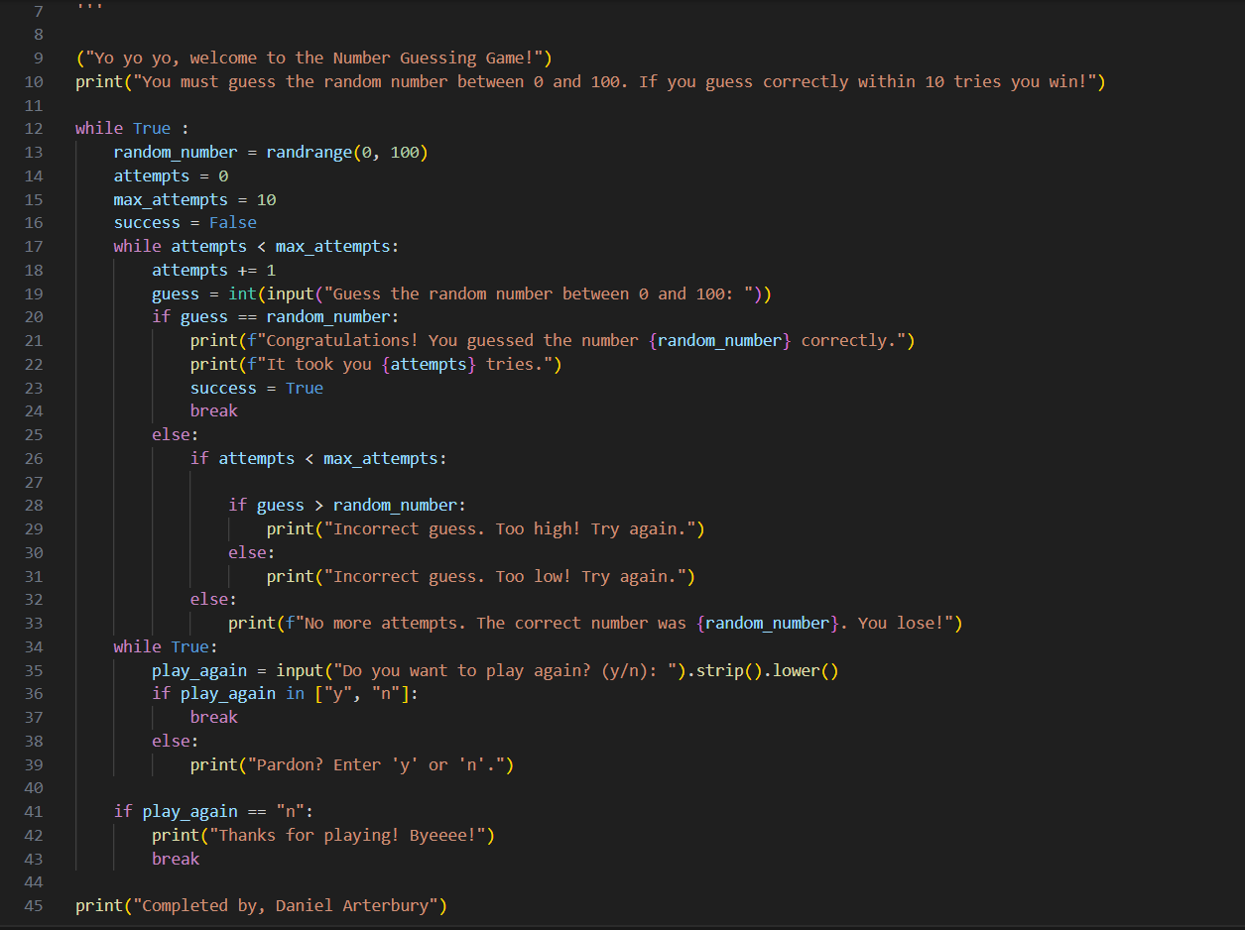
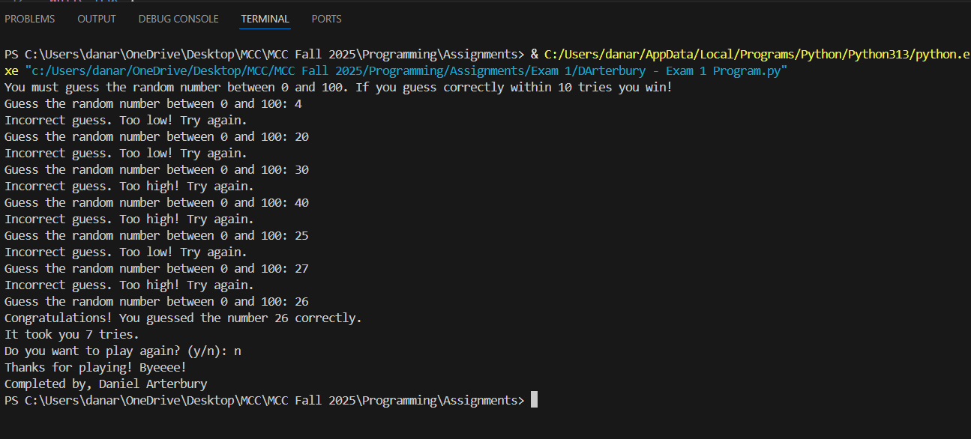
("Yo yo yo, welcome to the Number Guessing Game!")
print("You must guess the random number between 0 and 100. If you guess correctly within 10 tries you win!")

while True :
random_number = randrange(0, 100)
attempts = 0
max_attempts = 10
success = False
while attempts < max_attempts:
attempts += 1
guess = int(input("Guess the random number between 0 and 100: "))
if guess == random_number:
print(f"Congratulations! You guessed the number {random_number} correctly.")
print(f"It took you {attempts} tries.")
success = True
break
else:
if attempts < max_attempts:

if guess > random_number:
print("Incorrect guess. Too high! Try again.")
else:
print("Incorrect guess. Too low! Try again.")
else:
print(f"No more attempts. The correct number was {random_number}. You lose!")
while True:
play_again = input("Do you want to play again? (y/n): ").strip().lower()
if play_again in ["y", "n"]:
break
else:
print("Pardon? Enter 'y' or 'n'.")

if play_again == "n":
print("Thanks for playing! Byeeee!")
break

print("Completed by, Daniel Arterbury")

